LAB WORKBOOK-09.07.2026

1)Aim
To write a C program to square each element of a sorted array and return the squared values in sorted order using the Two-Pointer Technique
Pseudocode
Algorithm: Squaring a Sorted Array

Step 1: Start.

Step 2: Read the number of elements N.

Step 3: Read the sorted array elements.

Step 4: Initialize
left = 0,
right = N - 1,
index = N - 1.

Step 5: Repeat while left <= right.

a) Compare |arr[left]| and |arr[right]|.

b) If |arr[left]| > |arr[right]|
result[index] = arr[left] × arr[left]
Increment left.

Else
result[index] = arr[right] × arr[right]
Decrement right.

c) Decrement index.

Step 6: Print the result array.

Step 7: Stop.

C Program
#include <stdio.h>
#include <stdlib.h>

int main()
{
int n;
int arr[n], result[n];

scanf("%d", &n);

for(int i = 0; i < n; i++)
{
scanf("%d", &arr[i]);
}

int i = 0;
int j = n - 1;
int k = n - 1;

while(i <= j)
{
if(abs(arr[i]) > abs(arr[j]))
{
result[k] = arr[i] * arr[j];
i++;
}
else
{
result[k] = arr[j] * arr[j];
j--;
}
k--;
}

for(int i = 0; i < n; i++)
{
printf("%d ", result[i]);
}

return 0;
}

Screenshot of the Output

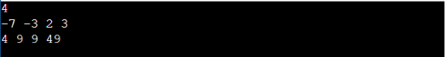

Result
Thus, the C program to square each element of a sorted array and display the squared values in sorted order using the Two-Pointer Technique was implemented and executed successfully. The expected output was obtained.
2)

Aim
To write a C program to compute the cumulative resource consumption (Prefix Sum Array) from the given array using the Prefix Sum Technique
Pseudocode
Algorithm: Cumulative Resource Consumption using Prefix Sum

Step 1: Start.

Step 2: Read the number of elements N.

Step 3: Read the array elements.

Step 4: Create a prefix sum array.

Step 5: Set
prefix[0] = arr[0].

Step 6: Repeat for i = 1 to N-1

prefix[i] = prefix[i-1] + arr[i].

Step 7: Print the prefix sum array.

Step 8: Stop.

C Program
#include <stdio.h>

int main()
{
int n;
int arr[n], result[n];

scanf("%d", &n);

for(int i = 0; i < n; i++)
{
scanf("%d", &arr[i]);
}

result[0] = arr[0];

for(int i = 1; i < n; i++)
{
prefix[i] = result[i - 1] + arr[i];
}

for(int i = 0; i < n; i++)
{
printf("%d ", result[i]);
}

return 0;
}
Screenshot of the Output
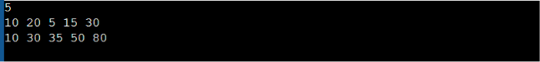


Result
Thus, the C program to compute the cumulative resource consumption using the Prefix Sum Technique was implemented and executed successfully. The expected output was obtained.

3)

Aim
To write a C program to find the minimum number of swaps required to group all active sectors (1s) together using the Fixed-Size Sliding Window Technique.
Pseudocode

Algorithm: Grouping Active Sectors

Step 1: Start.

Step 2: Read the number of elements N.

Step 3: Read the binary array.

Step 4: Count the total number of 1s in the array.
Let this count be C.

Step 5: If C is 0 or 1,
Print "Min Swaps: 0"
Stop.

Step 6: Count the number of 1s in the first window
of size C.
Store it in currentOnes.

Step 7: Initialize
maxOnes = currentOnes.

Step 8: Slide the window from index C to N-1.

a) If the new element is 1,
Increment currentOnes.

b) If the outgoing element is 1,
Decrement currentOnes.

c) Update maxOnes if currentOnes is greater.

Step 9: Compute

MinSwaps = C - maxOnes.

Step 10: Print
"Min Swaps: X".

Step 11: Stop.

C Program

#include <stdio.h>

int main()
{
int n;
int arr[n];
int count = 0;

scanf("%d", &n);

for(int i = 0; i < n; i++)
{
scanf("%d", &arr[i]);

if(arr[i] == 1)
count++;
}

if(count <= 1)
{
printf("Min Swaps: 0");
return 0;
}

int current = 0;

for(int i = 0; i < count; i++)
{
if(arr[i] == 1)
current++;
}

int maxx = current;

for(int i = count; i < n; i++)
{
if(arr[i] == 1)
current++;

if(arr[i - count] == 1)
current--;

if(current > maxx)
maxx = current;
}

printf("Min Swaps: %d", count - maxx);

return 0;
}

Screenshot of the Output
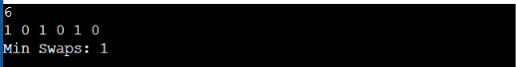

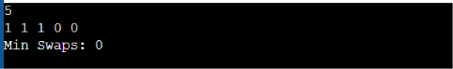

Result
Thus, the C program to find the minimum number of swaps required to group all active sectors together using the Fixed-Size Sliding Window Technique was implemented and executed successfully. The expected output was obtained.

4)

Aim
To write a C program to find the maximum number of consecutive tasks that can be executed without exceeding the given energy budget P using the Variable-Size Sliding Window Technique
Pseudocode

Algorithm: Maximum Task Window Within Budget

Step 1: Start.

Step 2: Read the values of N and P.

Step 3: Read the array elements.

Step 4: Initialize
start = 0,
currentSum = 0,
maxLength = 0.

Step 5: Traverse the array using end from 0 to N-1.

a) Add arr[end] to currentSum.

b) While currentSum > P

i) Subtract arr[start] from currentSum.

ii) Increment start.

c) Calculate currentLength = end - start + 1.

d) If currentLength > maxLength
Update maxLength.

Step 6: Print
"Max Length: X".

Step 7: Stop.

C Program

#include <stdio.h>

int main()
{
int n, p;
int arr[n];
int start = 0;
int currentSum = 0;
int maxLength = 0;

scanf("%d %d", &n, &p);

for(int i = 0; i < n; i++)
{
scanf("%d", &arr[i]);
}

for(int end = 0; end < n; end++)
{
currentSum += arr[end];

while(currentSum > p && start <= end)
{
currentSum -= arr[start];
start++;
}

if(currentSum <= p)
{
int currentLength = end - start + 1;

if(currentLength > maxLength)
{
maxLength = currentLength;
}
}
}

printf("Max Length: %d", maxLength);

return 0;
}

Screenshot of the Output

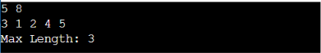

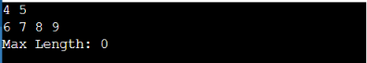

Result
Thus, the C program to find the maximum number of consecutive tasks that can be executed without exceeding the given energy budget using the Variable-Size Sliding Window Technique was implemented and executed successfully. The expected output was obtained.
5)

Aim
To write a C program to find the maximum element in every sliding window of size K using the Monotonic Queue (Deque) Technique.

Pseudocode

Algorithm: Sliding Window Maximum Peak

Step 1: Start.

Step 2: Read the values of N and K.

Step 3: Read the array elements.

Step 4: Initialize an empty deque to store indices.

Step 5: Traverse the array from i = 0 to N-1.

a) Remove indices from the front of the deque
if they are outside the current window.

b) Remove indices from the back of the deque
while the corresponding array value is
less than or equal to arr[i].

c) Insert the current index i at the rear
of the deque.

d) If the first window is formed
(i >= K - 1),
print the element at the front of
the deque as the maximum.

Step 6: Stop.

C Program

#include <stdio.h>

int main()
{
int n, k;
int arr[10000];
int deque[10000];
int front = 0, rear = -1;

scanf("%d %d", &n, &k);

for(int i = 0; i < n; i++)
{
scanf("%d", &arr[i]);
}

for(int i = 0; i < n; i++)
{
while(front <= rear && deque[front] <= i - k)
{
front++;
}

while(front <= rear && arr[deque[rear]] <= arr[i])
{
rear--;
}

deque[++rear] = i;

if(i >= k - 1)
{
printf("%d ", arr[deque[front]]);
}
}

return 0;
}

Screenshot of the Output
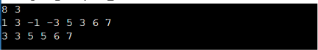


Result
Thus, the C program to find the maximum element in every sliding window of size K using the Monotonic Queue (Deque) Technique was implemented and executed successfully. The expected output was obtained.

